**CS4416 Group 26 Project**

**Made By:**

**Jakub Pa**žej 18260179

Aleksandr Jakusevs 18257038

Eoin McDonough 18241646

**Purpose of our Database:**

**We made a database for an imaginary game shop you could find anywhere in the city.**

**We have a customer table where external software would be able to add customers, then there is an Employee table where the shop management would be able to make changes through some sort of external software.  
In the shop, there is a table to purchase one of two products, either games or consoles.  
There are multiple copies of each game and console, each with their own unique product id.  
The consoles are customizable in their colour and memory size, and the games have different genres, prices and age rating.  
An external software would be able to see everything it needs to know about the employees and their sales, such as their names, genders, ages, wages, and sale ids. It can also see the quantity of items bought in any given sale, and when the sale took place.  
The software could also find out about the customer who bought the product, info such as their names, emails and address.**

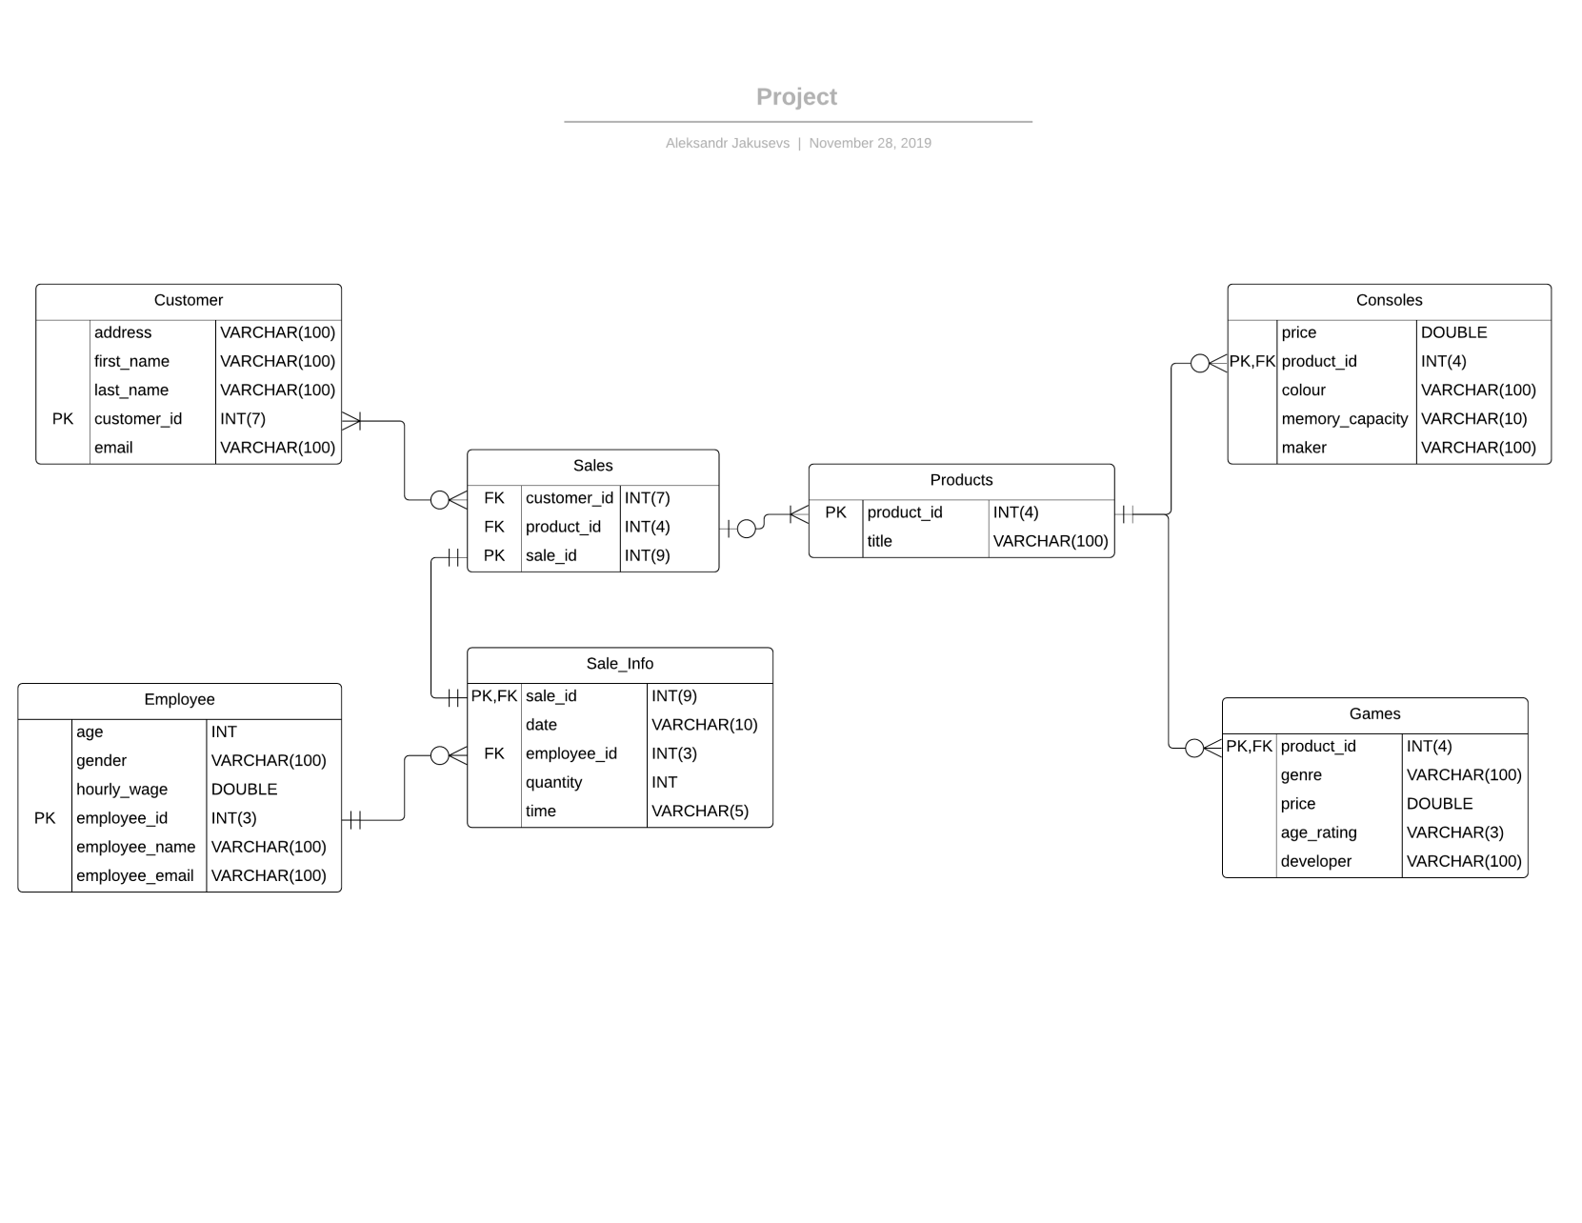

**Customer Table:**

Primary Key

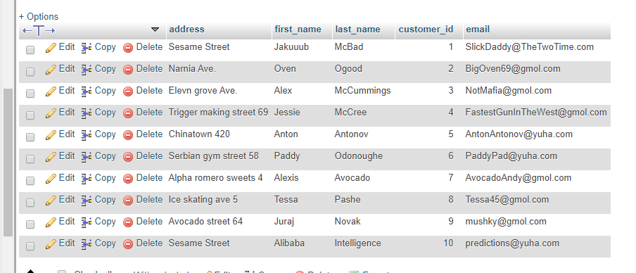

**Employee Table:**

Primary Key

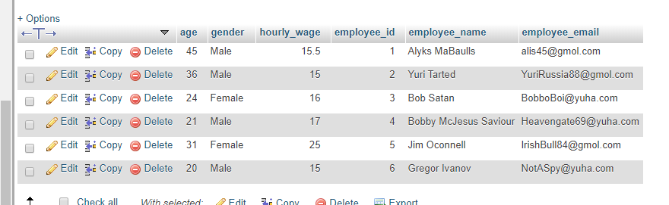

**Consoles Table:**

Primary and Foreign Key

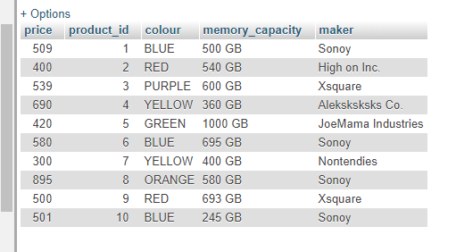

**Games Table:**

Primary and Foreign Key

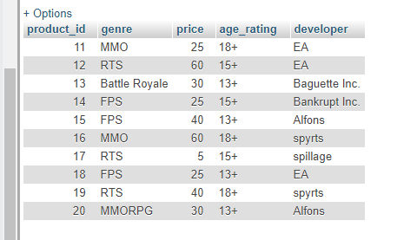

**Products Table:**

Primary Key

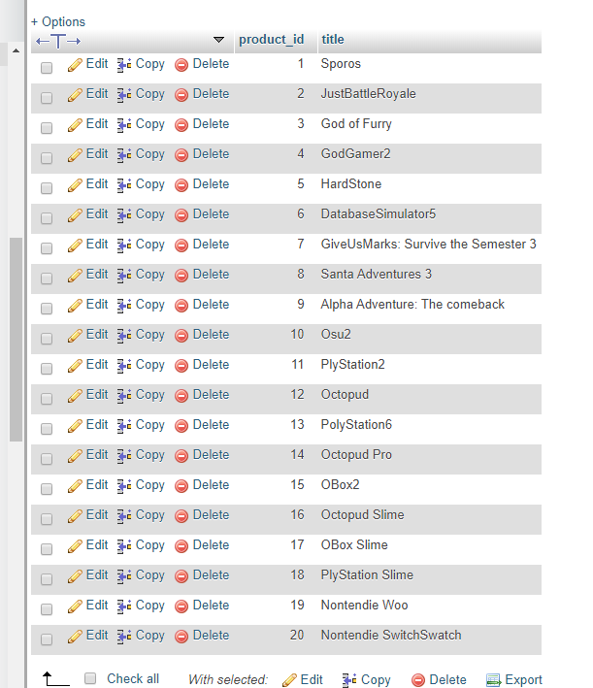

**Sales Table:**

Foreign Keys

Primary Key

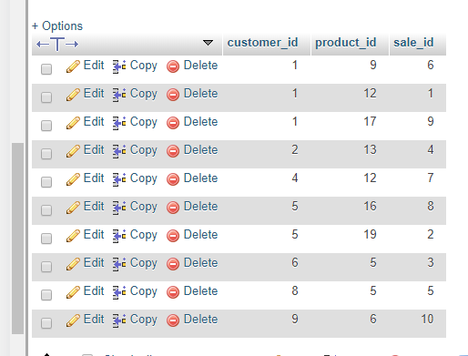

**Sale_info Table:**

Foreign Key

Primary and Foreign Key

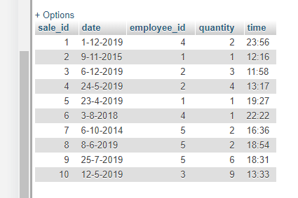

**The List of FDs for each table:**Customer - PK (primary key) customer_id   
Employee - PK employee_id   
Sales - PK sale_id, FK (foreign key) customer_id, FK product_id  
Sales_Info - PK/FK sale_id, FK employee_id   
Products - PK product_id   
Consoles - PK/FK product_id   
Games - PK/FK product_id

**Proof that each table is in 3NF:**   
For each of the tables each column contains a single value, each column contains values of the same type, each column has a unique name, the order in which the date is stored does not matter, there is no partial dependency and no column is dependent on a non-primary attribute.

**Justification of views:**

While designing the views for our database, we thought about what would be most likely to be asked repeatedly. First we decided to list the consoles by their price, only showing the ones that are above €499. This is useful data for the database to know. Then we listed all the games by a certain developer, in this case, EA, as this would be extremely useful for sorting software to make better sense of their data. For our last list, we wanted to list all the employees who makes over a certain amount of money an hour, as this is important for companies to keep an eye on their expenses.

**Analysis of the speed of the queries:**   
The queries work extremely quickly and efficiently as the FD's allow the database to pinpoint exactly what is being searched quite easily as all the foreign keys are labelled correctly and so are all the primary keys which allows for highly effective usage of the database's resources as it knows exactly where to look

**Justification of Triggers:**The triggers would allow quick and efficient logging of newly added games or removed games from the database. As games would be bought and sold quite often in a game store allowing for quick and efficient adding and removing of entries from the database as well as recording all the removed entries would allow for a quick efficient and highly useful database as it even accounts for things such as refunds